

**ECET 400: Senior Project**

**Design Specifications**

**Title Project: Automatic Rear-View Mirror**

**Professor:**

**Alex Blinder**

**Students:**

**Valentina Clavijo**

**Diego Andrade**

**Kyuung (Casey) Cha**

**Nigel Ng**

**Mohammad Rahman**

**Date: 10/21/24**

# **Table of Contents**

**Table of Contents 2**

**1.0 Product Summary 6**

**1.1 Project Originality 8**

**2.0 Requirements List 8**

**2.1 Power 8**

**2.2 Case 9**

**2.3 Technical 9**

**2.4 Camera 10**

**2.5 Software 10**

**2.6 Hardware 11**

**2.7 Cost 11**

**3.0 Specification Requirements 12**

**3.1 General Description 12**

**3.2 Power 13**

**3.2.1 Source 13**

**3.2.2 Voltage Current Requirements 13**

**3.3 Case 13**

**3.3.1 Description 13**

**3.3.2 Overall Size 15**

**3.3.3 Material 15**

**3.3.4 Special Features 16**

**3.4 Technical Requirements 17**

**3.4.1 Signal Inputs 17**

**3.4.2 Signal Outputs 18**

**3.4.3 Major Internal Signals 18**

**3.4.4 Microprocessor/Microcontroller Specifications 18**

**3.4.5 Memory Chips 19**

**3.4.6 Ports(s) 19**

**3.4.7 Keyboard(s) and Display(s) 19**

**3.4.8 Other 19**

**3.5 Operational Requirements 20**

**3.5.1 Auto Start 20**

**3.5.2 Camera Face / Eye Recognition 20**

**3.5.3 Motor Adjustment 21**

**3.5.4 Powered Adjustment 21**

**3.5.5 LED Light 21**

**3.6 Cost and Schedule 22**

**3.6.1 Materials and Cost Capped 22**

**3.6.2 Development and Cost Capped 22**

**3.6.3 Project Schedule 23**

**4.0 Top Level Block Diagram 24**

**5.0 Explanation of Diagram Sections 24**

**5.1 Camera Detection 24**

**5.2 Microcontroller 24**

**5.3 Motors 25**

**5.4 Mirror Adjustment 25**

**6.0 Second Level Block Diagram 26**

**6.1 Explanation of Diagram 26**

**7.0 Flowchart of the Program 28**

**8.0 Cost and Major Component Type 30**

**8.1 Appendix A Circuit Diagram 30**

**8.2 Appendix B Coding with Comments 31**

**8.3 Appendix C Potential Problems and Obstacles 35**

**8.3.1 Incorrect Eye Detection due to Obstructions 35**

**8.3.2 Undetachable Rear-View Mirror 35**

**8.3.3 Motor Adjustments 35**

**8.3.4. Parts Not Interacting Smoothly 36**

**8.3.5. LED Pilot Light Being a Distraction to the Driver and Other Drivers 36**

**8.4 Appendix D Bill of Materials 37**

**8.5 Appendix E Calculations 41**

**8.6 Appendix F Data Sheets 43**

**8.6.1 Raspberry Pi 4 Model B datasheet 43**

**8.6.2 Raspberry Pi Camera Module V2 datasheet 45**

**8.6.3 Greartisan Gear Motor datasheet 46**

**8.6.4 3 mm LED Datasheet 47**

**8.6.5 L293D Datasheet 48**

**9.0 References 50**

| **Table of Figures** | |
| --- | --- |
| **Figure** | **Page** |
| **Fig. #1: Ball Joint, Monopole Gear, and Motor Mechanism Interior** | **7** |
| **Fig. #2: Design of Ball Joint & Mirror Assembly** | **14** |
| **Fig. #3: Design of Mounting Assembly** | **14** |
| **Fig. #4: Automatic Rear-View Mirror Assembly** | **15** |
| **Fig. #5 Top Level Block Diagram** | **24** |
| **Fig. #6 Second Level Block Diagram** | **26** |
| **Fig. #7: Flowchart** | **28** |
| **Fig. #8: Circuit Diagram** | **30** |
| **Fig. #9: Schematic** | **31** |
| **Fig. #10: Adjustment Process Example** | **41** |
| **Fig. #11: Yaw Roll Pitch Diagram** | **42** |
| **Fig. #12: ABENICS Joint** | **42** |
| **Fig. #13: Raspberry Pi 4 Model B Pinout Diagram** | **43** |
| **Fig.** **#14: Minimum & Maximum Voltage Input** | **43** |
| **Fig. #15: Raspberry Pi Pinout Diagram** | **44** |
| **Fig. #16: Raspberry Pi Camera Module V2** | **45** |
| **Fig. #17: Greartisan DC 12V 10RPM, 37mm Diameter Gearbox** | **46** |
| **Fig. #18: 3mm LED Datasheet** | **47** |
| **Fig. #19 L293D Datasheet, Block Diagram** | **48** |
| **Fig. #20: L293D, Pin Connections** | **48** |

# 

# **1.0 Product Summary**

The automatic rear-view mirror uses eye-tracking software to detect eye movements and adjust the mirror accordingly via a micro camera attached below the mirror. This technology makes it easier and safer for drivers out on the road as their mirrors will always be properly aligned providing them with the best possible chance of avoiding an accident. Improper mirror adjustments often lead to having blind spots that lead to a higher likelihood of an accident occurring (Jiang et al, 2015)[1]. Families sharing vehicles and car sharing services have a greater need for this technology as the mirror is often adjusted when a new person/customer gets in the vehicle (Valentine, 2024)[2]. By using the position of the driver's eyes, the camera connected to the mirror will align itself with the eye line of the driver and position itself at the correct angle according to the rear window and driver. When the vehicle is turned on, the camera will immediately search for the driver's eyes by using dots projected onto the eyes, and perpendicular dots that serve as markers for the camera to align itself to the eye line of the driver. The system determines the angle of adjustment between both markers and signals the motors to start moving the ABENICS ball joint to then rotate to the optimal position. Once the mirror is facing the driver, the system will use dots placed at the rear window to determine where small adjustments are needed to allow for the best possible view of the rear window. Because the rotation and joint system uses the ABENICS joint, it will have full control over the pitch, yaw, and roll which allows for axial movement. Based on these parameters, the rear-view mirror will not need adjustment via user input. If the automatic feature fails to function properly, the product comes with a powered adjustment that will use the directional pad that most vehicles use to adjust their powered side-view mirrors. To prevent the adjustment from being interrupted, the system will warn the driver when the adjustment will be occurring via an LED light that will produce momentary oscillations and will turn off once the adjustment is complete.

The product will have a front facing rear-view mirror that will be attached to the ABENICS ball joint via an extruding part of the ball that will be attached to the mirror back cover. The ball joint, Raspberry Pi, and motors will have their own housing that will be attached to the roof/windshield of a vehicle. The ball joint will have a special housing to keep the ball in place and allow access for the motorized rotation. Motor 1 will be placed under the ball joint connected to the monopole gear and motor 2. Motor 1 will be used to directly control the roll axis of the ball joint which in turn will rotate Motor 2 alongside the monopole gear and ball joint. Motor 2 will rotate along the wall via support structure to keep it in place and allow for seamless movement. Motor 2 will control pitch and yaw as it is able to switch angles thanks to Motor 1 controlling roll. The wiring will be internal and will be wired through the inside of the ABENICS ball joint and to the mirror.

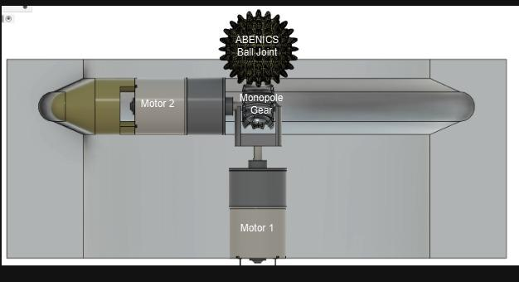

#### **Figure #1: Ball Joint, Monopole Gear, and Motor Mechanism Sliced View**

## **1.1 Project Originality**

A recent study conducted by the Tongmyong University Industrial-Academic Cooperation Foundation (2020) explored the potential of eye-tracking technology for rear-view mirror adjustment, highlighting its benefits for enhancing driver safety and addressing issues such as blind spots and improper mirror alignment. However, there are few things that sets this project apart from the study. This project introduces an original solution, with approximately 60% of its design being innovative, building on the foundational research and transforming the concept into a practical, market-ready system. Unlike the previously mentioned study, the eye-tracking automatic rear-view mirror adjustment system uses only eye-tracking for automatic adjustment and also has the option of a manual operation mode similar to adjusting a driver’s side view mirror. In addition, there is a safety indicator LED that alights before and while adjustments are being made to the rear-view mirror.

# **2.0 Requirements List**

## **2.1 Power**

The power necessary to activate all the devices and components used to control and adjust the motors behind the mirror. For the product, power will be sent from a 5V power adaptor which will first power the Raspberry Pi microcontroller which will subsequently power the other components. In addition to the source, the voltage and current requirements would vary from component to component, however, for most of the components 3.3V or 5V provided to them would be sufficient enough to allow them to run optimally.

## **2.2 Case**

The case would be the housing unit used to store the bulk of the main components, specifically the DC motors, gear, and the mirror, while the rest of the components, the Raspberry Pi microcontroller and directional pad would be installed separately for the prototype. The main housing unit would be a plastic casing holding the DC motors situated with one on the side and the other in the rear. While the rear-view mirror itself would be situated at the front of the housing unit held in by the abenics joint.

## **2.3 Technical**

The technical requirements would involve all the specifications of nearly every component used for the project. Which includes the signal inputs and outputs for the components, that being the voltage and current running through the microcontroller, the directional pad, and pushbuttons, as well as the camera, LED pilot light, and the DC motors. In addition, to the resistors and capacitors used to regulate the voltage passing through each component.

## 

## **2.4 Camera**

The camera needed for face and eye detection must be able to interface with the microcontroller and activate when the vehicle is powered on. It will detect the driver’s face, pinpoint the location of their eyes, and send this data to the microcontroller for further processing.

## **2.5 Software**

The software must be able to process real time data and allow the interface between the Raspberry Pi and the camera to analyze the driver’s eye positions and the current brightness level of the car. Based on the information collected, the software must be capable of controlling each axis of the motors and adjust the LEDs lights. The software will require minimal user control and be able to process adjustments automatically.

## 

## **2.6 Hardware**

Hardware must be able to completely resolve all the necessary functions and objectives reserved for the product. It must include a camera that will allow the software to detect the driver’s eyes and rear markers. A microcontroller that has enough inputs/outputs and power that allow for proper interface between components. Two motors with enough torque to adjust the rear-view mirror. Two LEDs capable of interfacing with the microcontroller as outputs. A case that will be able to hold all the components safely and sturdily with proper interface between mirror and ball joint. The case cannot impede the view of the driver.

## **2.7 Cost**

The cost is calculated based on the needs of the project and covers for contingencies and risks associated with the product. Cost will cover the necessary material such as motors, Raspberry Pi, camera, LEDs, resistors, wires, prototype materials, etc. It should also cover outside facilities used to put together parts of the product. The cost should cover replacement parts and any unpredicted costs that come up when testing is being conducted and parts of the product need improvement. See 8.4 Appendix D. Bill of Materials for more information on costs.

# 

# **3.0 Specification Requirements**

## **3.1 General Description**

The software must process the information inputted from the camera which detects the face and eye movements of the driver. The system then must confirm the presence of a driver in the vehicle to initiate the rear-view mirror adjustment process. If a driver is detected, the system must then determine the position of the eye line of the driver to the camera. Once the position is determined, the system needs to adjust and rotate the rear-view mirror. The system must instruct the motors to rotate accordingly to adjust to the driver's eye line and the rear-view mirror. While the system is adjusting automatically it must warn the driver of its action so that the driver is aware of the process and does not interfere with the process. To warn the driver, the system must use LEDs to intermittently turn on and off the warning light to serve as a clear indication of the adjustment. For the system to work properly it must be able to detect the driver in the dark as well, this means the system needs to use another LED to brighten the surroundings of the vehicle to allow for a clear view of the driver and rear window.

The microcontroller must be capable of powering two DC motors, two LEDs, and one camera. The power required for each will need to be gathered from the component data sheet. The two DC motors must be capable of turning the weight of the rear-view mirror, two LEDs, one camera, and the mirror case. The camera must interact with the microcontroller and have enough resolution for the software to detect and recognize the driver's face and eyes in the day and slightly dark space. The warning light must be apparent enough for the driver to notice the adjustment. The camera light must be bright enough to light the inside of a dark vehicle.

## 

## **3.2 Power**

### **3.2.1 Source**

The microcontroller must be sourced via a power adaptor connected to the wall as a part of the prototype. The two motors have to be sourced from the microcontroller or powered via an independent source depending on project needs. The two LEDs and camera will be sourced from the microcontroller as well.

### **3.2.2 Voltage Current Requirements**

The microcontroller will need a 5 volts power supply capable of supplying 3 amperes. The two motors require 12 volts at 1 amperes, the independent power source will be capable of producing 12.7 volts at 4 amps. The system must reduce the voltage to have a controlled rotation of the dc motors, this is where the motor driver comes in handy. The LEDs require 3 volts at 25 milliamperes. The camera requires 3.3 volts.

## **3.3 Case**

### **3.3.1 Description**

The case will contain the Raspberry Pi 4, two 10 RPM 12 volts DC motors, an ABENICS ball joint, two LEDs, a rear-view mirror, resistors, and wires to allow the connections. The implementation of 3D printing will allow the design of the ball joints, cover, and back plate. The case will have proper ventilation to keep the components at a moderate temperature. Moreover, the case will ensure access to external devices, such as HDMI, USB, and power supply.

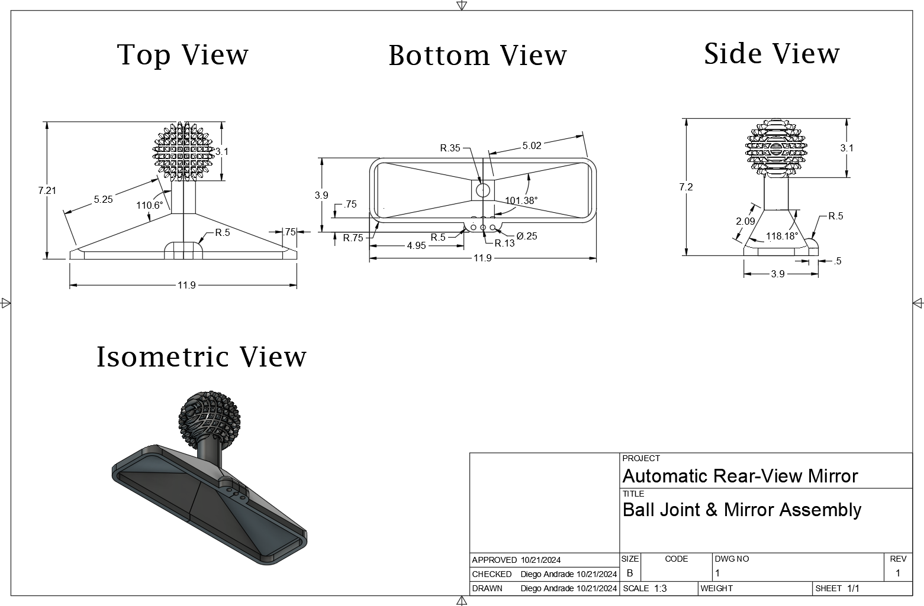

#### **Figure #2: Design of Ball Joint & Mirror Assembly**

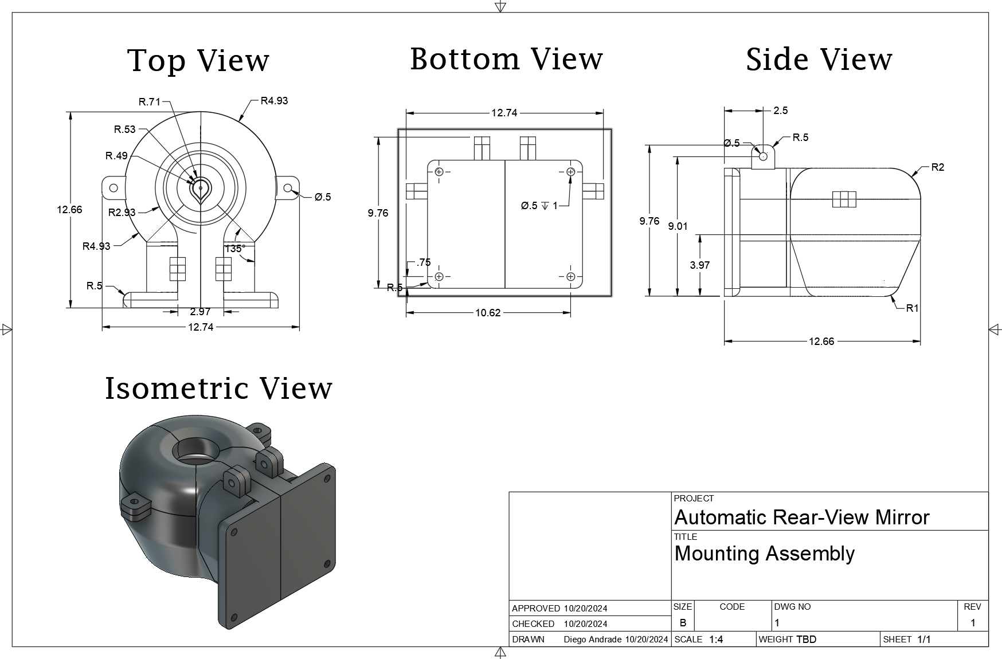

#### **Figure #3: Design of Mounting Assembly**

### 

### **3.3.2 Overall Size**

**Height:** 12.0 inch

**Width:** 12.0 inch

**Depth:** 10.0 inch

### **3.3.3 Material**

**Case rear-view mirror:** plastic

**Mirror:** glass

**Ball joint:** polylactic acid (PLA)

**Cover:**  polylactic acid (PLA)

**Back Plate:** polylactic acid (PLA)

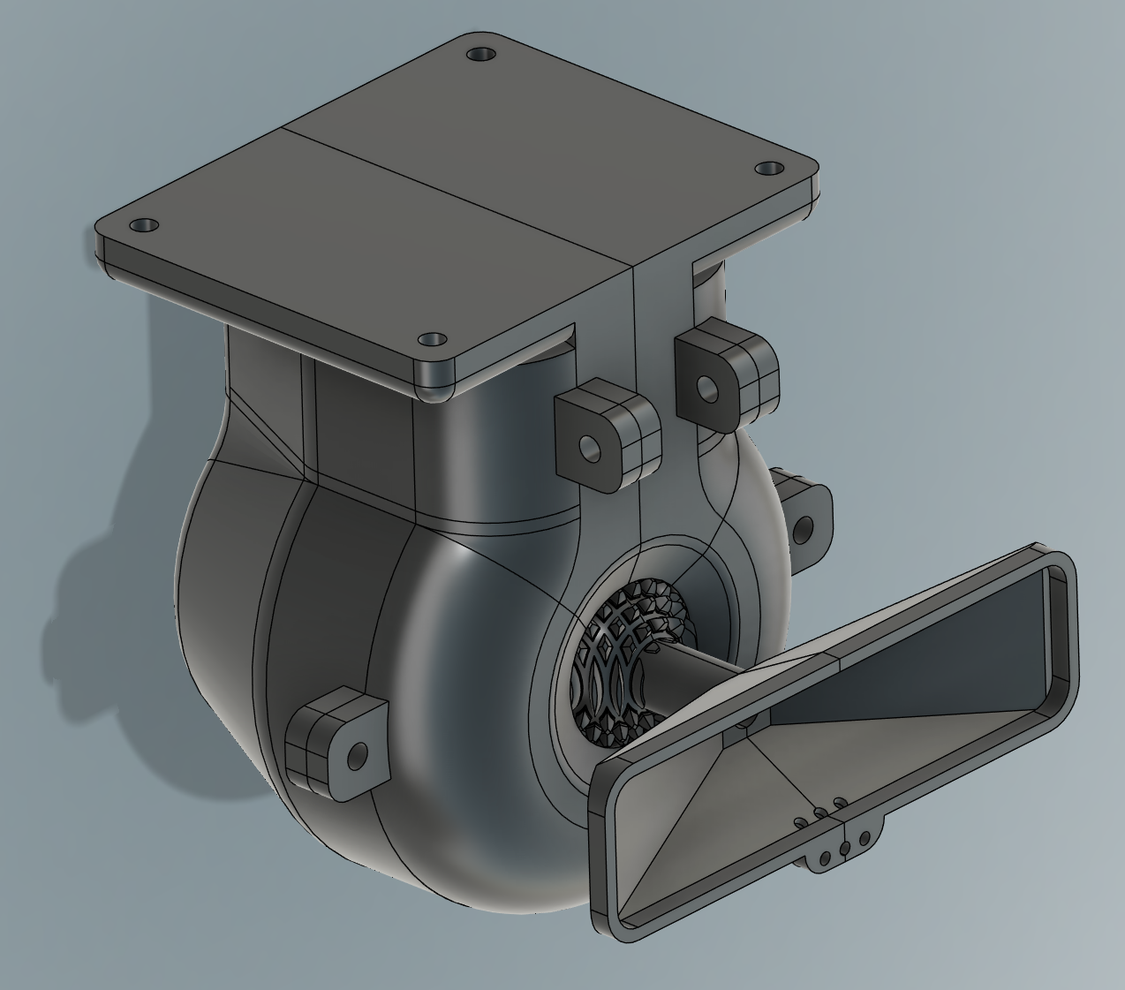

#### **Figure #4: Automatic Rear-View Mirror Assembly**

### 

### **3.3.4 Special Features**

1. **Access to ports:**
   * The design will allow access to USB, HDMI and power ports for the Raspberry Pi. This will ensure access to external devices.
2. **Ventilation:** 
   * The case will include windows that will ventilate the components and will keep them at a moderate and controlled temperature.
3. **Multidirectional Axial Movement:**
   * The design will use the ABENICS ball joint which provides multidirectional pitch, yaw, and roll rotations. It will be capable of turning in any direction at specified angles with small constraints.
4. **Powered Adjustment Mode**
   * The design will allow the use of powered adjustment using a control pad in case the automatic feature fails to function properly which can be due to hardware or software issues.

## 

## **3.4 Technical Requirements**

### **3.4.1 Signal Inputs**

* **Camera module V2:**
  + Capable of detecting the driver's face and eyes to send data (input) to the microcontroller.
* **Directional Pad:**
  + It will be able to receive instructions from the driver to send data to the microcontroller and adjust the rear-view mirror.
* **Select Button:**
  + It will allow switching modes between powered by directional pad and automatic adjustment. The commands will be sent as inputs to the microcontroller.

### 

### **3.4.2 Signal Outputs**

* **Warning Light:**
  + The warning light will blink during the adjustment process to warn the driver not to start the vehicle until the adjustments are fully completed
* **Camera Light:**
  + The camera light will be activated when the brightness level of the car is detected to be too dark for the microcontroller to detect the face. It will stay on until the adjustment process is complete
* **Motors:**
  + Receive the instructions from the microcontroller to be activated. This will perform the movement of the rear-view mirror to be adjusted.

### **3.4.3 Major Internal Signals**

Raspberry Pi 4 will process the data received by the camera V2. Processing the data and sending information from the inputs to the outputs will allow the correct adjustment of the rear-view mirror.

### **3.4.4 Microprocessor/Microcontroller Specifications**

Raspberry Pi 4 model B must be compatible with the two motors, camera, and LEDs. It must be able to process and use the data that the inputs are providing it. Use that data and produce outputs that control the motors, LEDs, and camera to adjust the rear-view mirror.

### **3.4.5 Memory Chips**

RAM from the microcontroller Raspberry Pi 4 allows the product to store and process real-time data received by the input of the camera. The system will remember the last position saved by the user.

### **3.4.6 Ports(s)**

The power port will maintain connection between the Raspberry Pi 4 and the car, allowing the car to supply power and automatically turn on the Raspberry Pi 4 when the engine starts.

### **3.4.7 Keyboard(s) and Display(s)**

Instead of using a keyboard or display, the Directional Pad will be used for any direct interaction between the driver and the Raspberry Pi 4 when necessary.

### **3.4.8 Other**

There are no other specific technical requirements for this project, other than what has already been specified above.

## 

## **3.5 Operational Requirements**

### **3.5.1 Auto Start**

The system must power on automatically when the car is started, without requiring manual activation by the driver. It will draw power through the vehicle’s USB connection to ensure seamless operation. This feature ensures that the system is always ready for use as soon as the vehicle is in motion.

### **3.5.2 Camera Face / Eye Recognition**

The camera must detect the presence of the driver upon entry into the vehicle. It should accurately identify the driver's face and calculate the correct coordinates of the eyes. This data will be used to adjust the rearview mirror automatically for optimal visibility.

### 

### **3.5.3 Motor Adjustment**

The system must accurately calculate the angular values based on the driver’s eye coordinates. It should then adjust the rearview mirror to the optimal angle for safe driving, ensuring precise positioning. The calculation must be highly accurate to guarantee the ideal mirror angle for each driver.

### **3.5.4 Powered Adjustment**

In case of system failure or unusual circumstances, the driver must be able to manually adjust the rearview mirror. The control pad, conveniently placed near the driver’s seat, will allow for precise mirror control. This ensures continued functionality even if the automatic system is compromised.

### **3.5.5 LED Light**

The system will include two lighting features: one designed to illuminate the car interior, enabling the camera to clearly capture the driver's face for accurate facial recognition even when it is dark. This also means that the system should be able to recognize the lighting condition of the car. The second feature serves as an alert, notifying the driver when the rearview mirror is being adjusted, ensuring they do not inadvertently drive off before the adjustment process is complete.

## 

## **3.6 Cost and Schedule**

### **3.6.1 Materials and Cost Capped**

The materials listed above are chosen specifically to be used for the project as a means to be the best use functionally. The choice was to not exceed a cost of no less than $200 as to keep production costs low in the case that production and manufacturing should ever occur. The choice to use inexpensive materials such as the resistors, wires, LEDs, and directional pad is that bulk ordering would be less costly, therefore most of the budget would instead be spent on the motors, Raspberry Pi microcontrollers, and camera.

### **3.6.2 Development and Cost Capped**

For development costs most of if not all non-electronic materials would be made using a 3D printer, while development for the eye tracking software is built from scratch. Things such as the monopole gear, ball & socket joint and the case housing would be made using a 3D printer where cost would be based on how much filament is used for the parts, so long as reprinting the parts a second time is not needed. Whereas the software requires no additional cost as the coding language has already been provided and purchased from either associated access granted by NJIT or by purchasing and downloading prior to the development of the project.

# 

### **3.6.3 Project Schedule**

The project should be completed within the next 4-5 weeks. The team has already finished the research and identified any risks or constraints of the design. It took around a week to come up with a reasonable budget and as of now all the components have been purchased. In order to manage the project, the team created a gantt chart to keep track of the timeline, progress,and deadlines. After several meetings were held, the team compiled all their research to complete the specific functions and concepts document. Flowcharts and drawings were created for the software and hardware integration. The initiation phase of the project is complete and the prototype is still in progress which is expected to be completed in around a week as the software still needs to be fixed and the 3D printed joints are in development with almost 75 % of it done. The execution of the project will begin one week after research is gathered, which then the team can proceed to creating a working prototype which will combine the hardware and the software along with addressing any risks associated with the design. Then finally the team will move on to the next phase of testing and validating the design.

# **4.0 Top Level Block Diagram**



#### **Figure #5: Top Level Block Design**

# **5.0 Explanation of Diagram Sections**

## **5.1 Camera Detection**

The camera detection block focuses on what the camera does and what it will operate once it is powered. Once turned on it will scan and detect the location of the driver’s eye line, then it will send that data to then be processed and activate the DC motors.

## **5.2 Microcontroller**

The microcontroller block focuses on processing the data that is sent from the camera as well as enabling other applications and components it’s connected to. Those components being pushbuttons to enable automatic operation with the camera and the eye tracking software, or manual operation with the directional pad. In addition, to the motor drive and connected DC motors to move the monopole gear to adjust the yaw, pitch, and roll of the mirror. Finally, an LED pilot to indicate when the rear-view mirror is adjusting when in automatic operation.

## 

## **5.3 Motors**

The motors block focuses on how the DC motors and the monopole gear will work to make micro adjustments to the mirror to offer the best angle for the driver to see out the back windshield. Using the data received and processed by the camera and microcontroller it will tell the motors to begin moving the ABENICS ball joint for optimal positioning.

## **5.4 Mirror Adjustment**

The mirror adjustment block focuses on what will occur as final adjustments will be made. When the mirror is in place facing the driver, the microcontroller and camera will scan for dots placed at the rear windshield to make additional adjustments giving the driver a better view out the windshield.

# **6.0 Second Level Block Diagram**

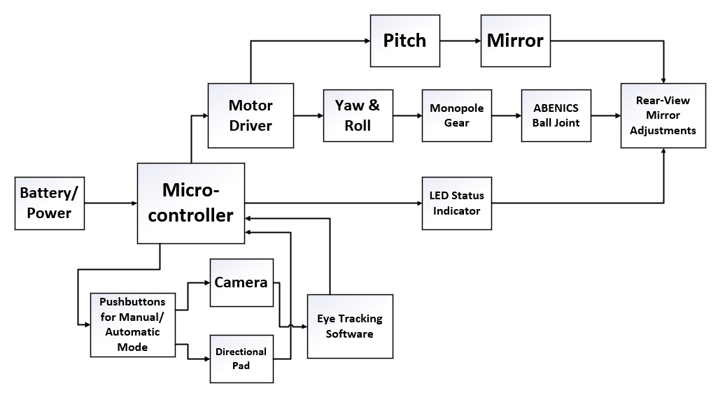

#### **Figure #6: Second Level Block Design**

## **6.1 Explanation of Diagram**

The first section of the second level block diagram is where the power is sourced either from a 5V adaptor or a 9V battery for the prototype or from the battery of a motor vehicle for a fully functional product. The next section is the microcontroller where the data is retrieved from the camera to be processed and will then be sent to the motors to move the monopole gear to then readjust the ball & joint assembly finally adjusting the rear-view mirror. Moving down to the next block are the pushbuttons, which allows the driver to adjust the rear-view mirror either by automatic adjustment via the camera and eye tracking software or by using manual operation with the direction pad. The eye tracking software block focuses on locating the eye position of the driver to then send that information for the microcontroller to process and subsequently tell the DC motors to move accordingly.

The motor driver block is the IC used to control the speed and direction of the motors either clockwise or anticlockwise and can drive up to 2 DC motors. The motor block focuses on the DC motors used to control the pitch, yaw and roll of the mirror, where one motor is located on the left side internal wall of the housing unit facing the cabin, which controls the pitch & yaw of the mirror. While the other motor will be located on the back wall of the housing unit which controls the roll of the mirror. The monopole gear block focuses on the gear that will be used for the smooth movement to change the angle of the mirror more seamlessly. The ball & socket joint block focuses on movement for the rear-view mirror when attached to the housing unit allowing for smoother movement when the driver or micro controller is adjusting it. The rear-view mirror adjustment block focuses on the micro adjustments made to the rear-view mirror offering the driver a better viewing angle out of the rear windshield. The LED status indicator block is the small pilot light used as indication for the driver, showing that automatic adjustments are being made once the power has been turned on for the microcontroller.

# **7.0 Flowchart of the Program**

#### **Figure #7: Flowchart**

The initialization of the Automatic Rear-View Mirror System begins when the driver starts the car. Once powered on, the car’s USB port activates the Raspberry Pi, along with the motor and camera. The Raspberry Pi is configured to automatically run the required Python program at boot, initiating the necessary systems for face detection, including loading the face detection models.

In the preparation stage, the system first checks the ambient lighting conditions using screen saturation values. If the environment is too dark, an Camera Light is activated to enhance visibility for driver detection. The system then scans for the driver's face to confirm their presence. In cases where the vehicle has been remotely started, the system waits for 20 seconds before performing another detection cycle. Once the driver’s face is detected, the warning light will begin blinking to notify the driver that the adjustment process is underway.

The calculation stage begins by detecting the driver’s eye coordinates using the face detection model. Once detected, reference dots are placed on the eyes on the display. Additionally, two target dots appear, representing the optimal reference dot positions for the ideal rear-view mirror angle. The system calculates the distance between the reference dots and the target dots, determining how much the mirror needs to be adjusted to align the two.

The adjustment stage is the core function of the system. The Raspberry Pi signals the motors connected to the monopole gear to move to adjust the ball joint mount to rotate the mirror along its X, Y, and Z axes based on the distance calculations. Once the reference dots align with the target dots, the system performs a final scan to verify the alignment between the driver’s face and the windshield. Upon completion of the final scan, the adjustment process concludes, ensuring optimal rear-view visibility for the driver.

# **8.0 Cost and Major Component Type**

## **8.1 Appendix A Circuit Diagram**

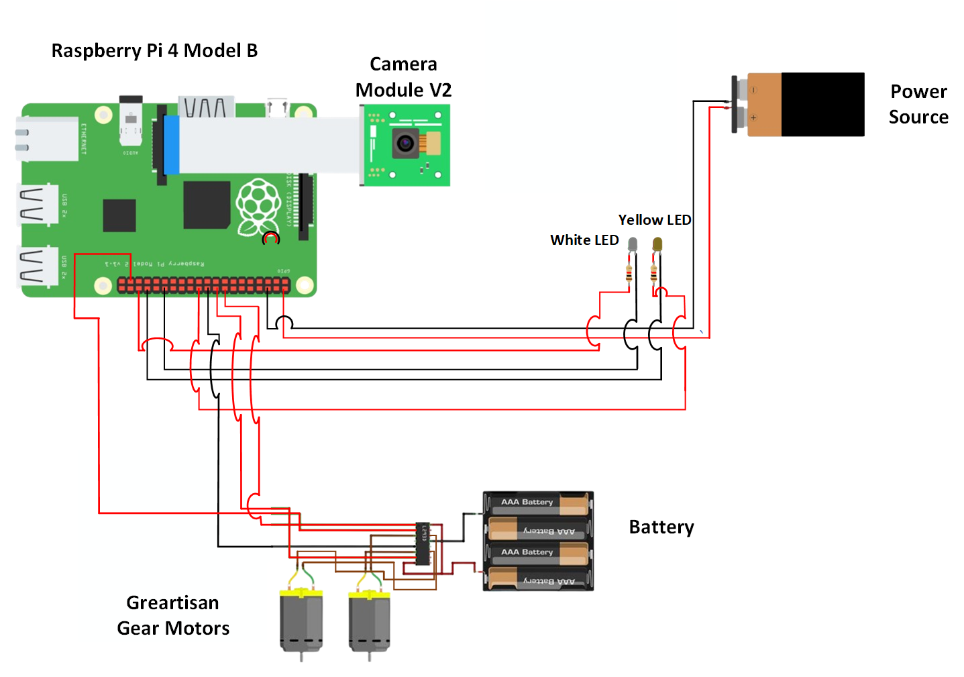

#### **Figure #8: Circuit Diagram**

#### 

## 

#### **Figure #9: Schematic**

## 

## **8.2 Appendix B Coding with Comments**

**Github:** [**https://github.com/soulcasey/Senior-Project/blob/main/EyeTracking.py**](https://github.com/soulcasey/Senior-Project/blob/main/EyeTracking.py)

import cv2

import mediapipe as mp

**# Initialize MediaPipe's holistic model**

**# Will be using the most basic model for prototype**

mp_holistic = mp.solutions.holistic.Holistic(min_detection_confidence=0.9, min_tracking_confidence=0.9)

**# Camera setup**

cap = cv2.VideoCapture(0, cv2.CAP_DSHOW)

cap.set(cv2.CAP_PROP_FRAME_HEIGHT, 600)

cap.set(cv2.CAP_PROP_FRAME_WIDTH, 800)

cap.set(cv2.CAP_PROP_FPS, 30)

**# Set target points**

**# The left target point is placed on the right as the driver’s face is inverted in camera’s perspective**

frame_width, frame_height = int(cap.get(cv2.CAP_PROP_FRAME_WIDTH)), int(cap.get(cv2.CAP_PROP_FRAME_HEIGHT))

target_point_left = (frame_width // 2 +25, frame_height // 2)

target_point_right = (frame_width // 2 - 25, frame_height // 2)

def draw_point(img, color, position):

cv2.circle(img, position, 5, color, -1)

while True:

ret, frame = cap.read()

frame_rgb = cv2.cvtColor(frame, cv2.COLOR_BGR2RGB)

results = mp_holistic.process(frame_rgb)

**# If face has been detected**

if results.pose_landmarks:

**# Extract left and right eye keypoints**

left_eye = (

int(results.pose_landmarks.landmark[mp.solutions.holistic.PoseLandmark.LEFT_EYE].x * frame_width),

int(results.pose_landmarks.landmark[mp.solutions.holistic.PoseLandmark.LEFT_EYE].y * frame_height)

)

right_eye = (

int(results.pose_landmarks.landmark[mp.solutions.holistic.PoseLandmark.RIGHT_EYE].x * frame_width),

int(results.pose_landmarks.landmark[mp.solutions.holistic.PoseLandmark.RIGHT_EYE].y * frame_height)

)

**# Draw the left and right eye reference points along with their target points**

draw_point(frame, (0, 0, 255), left_eye)

draw_point(frame, (0, 255, 0), target_point_left)

draw_point(frame, (0, 0, 255), right_eye)

draw_point(frame, (0, 255, 0), target_point_right)

**# Calculate movement to align the reference point to the target point**

**# Only to basic distance calculation for now**

x_movement_left = target_point_left[0] - left_eye[0]

y_movement_left = target_point_left[1] - left_eye[1]

x_movement_right = target_point_right[0] - right_eye[0]

y_movement_right = target_point_right[1] - right_eye[1]

**# Display coordinate and calculation informations on screen for prototype**

cv2.putText(frame, f"RightEyePos: {right_eye}", (10, 30), cv2.FONT_HERSHEY_SIMPLEX, 1, (0, 0, 255), 2)

cv2.putText(frame, f"MovTo: ({x_movement_right}, {y_movement_right})", (10, 70), cv2.FONT_HERSHEY_SIMPLEX, 1, (0, 0, 255), 2)

cv2.putText(frame, f"LeftEyePos: {left_eye}", (10, 110), cv2.FONT_HERSHEY_SIMPLEX, 1, (0, 0, 255), 2)

cv2.putText(frame, f"MovTo: ({x_movement_left}, {y_movement_left})", (10, 150), cv2.FONT_HERSHEY_SIMPLEX, 1, (0, 0, 255), 2)

**# Adjustment process will go here once motor is complete**

**# Check if the points are overlapped**

if abs(x_movement_left) <= 3 and abs(y_movement_left) <= 3 and abs(x_movement_right) <= 3 and abs(y_movement_right) <= 3:

cv2.putText(frame, "GOOD!", (10, 190), cv2.FONT_HERSHEY_SIMPLEX, 1, (0, 255, 0), 2)

if cv2.waitKey(1) & 0xFF == ord('q'):

break

cap.release()

cv2.destroyAllWindows()

## 

## 

## **8.3 Appendix C Potential Problems and Obstacles**

### **8.3.1 Incorrect Eye Detection due to Obstructions**

Eye detection could potentially become unreliable in certain situations, leading to inaccurate positioning in systems dependent on precise eye-tracking data. Obstructions like sunglasses or hair may block or distort the visibility of the driver’s eyes, causing eye-tracking algorithms to struggle in detecting accurate coordinates. Although using face angle to predict eye location can partially address this issue, it often results in reduced precision and accuracy, limiting the overall effectiveness of the system.

### **8.3.2 Undetachable Rear-View Mirror**

Although the one-fit-all ball joint mount is designed to be universally compatible with various car rearview mirrors, some vehicles with unique mirror designs may not fit this configuration. Certain modern cars have rear-view mirrors integrated directly into the vehicle, making it challenging to attach the mount. However, these cars typically come equipped with advanced technologies, reducing the need for an automatic rearview mirror in such cases.

### **8.3.3 Motor Adjustments**

The motor can have delayed response and not adjust as quickly as expected after tracking the driver’s eye movements. This can be tackled by using the manual adjustment to control the rearview mirror instead of relying on the eye tracking or user repositioning to enhance the tracking system.

### **8.3.4. Parts Not Interacting Smoothly**

The components in the system may not work seamlessly as expected. The abenics joint being a new technology may not move as smoothly with the motors. This may cause the system to have delays or inaccuracies.

### **8.3.5. LED Pilot Light Being a Distraction to the Driver and Other Drivers**

The chance that the LED pilot light becomes a potential distraction when it alights. The indicator LED light would only activate once the vehicle turns on, it would flash in intervals during the adjustment process and will turn off once finished. The automatic rear-view mirror adjustment would not occur when the vehicle is in motion.

## **8.4 Appendix D Bill of Materials**

| **Component** | **Part Number** | **Description** | **Quantity** | **Cost Per Unit** | **Total Cost** |
| --- | --- | --- | --- | --- | --- |
| Raspberry Pi | 4 model B | [Pi 4 4GB Board Only](https://www.canakit.com/raspberry-pi-4-4gb.html?cid=usd&src=raspberrypi) | 1 | $55.00 | $55.00 |
| First Motor | DC 12V 550 RPM | [Greartisan DC 12V 550 RPM Gear Motor High Torque Electric Micro Speed Reduction Geared Motor Centric Output Shaft 37mm Diameter Gearbox](https://www.amazon.com/Greartisan-Electric-Reduction-Centric-Diameter/dp/B072R5G5GR/ref=sr_1_6?dib=eyJ2IjoiMSJ9.DVWk5pLyQ_dqDp13O4lPtXmWJI-1PIDOGCXkdHtBmk8kIkbhaTpLe9H5dfid5uMbi3GzMdo-mdpM9U8yt_FHOFVe13uaeaJHaaeGRUdknU6j9w-tYt_hyOkCkRMPB_9s2DW1F7Xw3hzCqTFcXVQwW-q_n5dNwxl1b7ungHc3w41trYXV6S-P7GOEoIbjEFxIls6oe45XqJGevlB48n9pdQJbXKD7HJbBAeXC8EXyC2a_fwVbRS_tMMk0esKfpy7AN52JDr3jkJSRhn0bDPy_KWWrOlS1TwtlI6wbIr6yOF4.R0z_GKXggYmb6AjWPk86apT7ntOMUQBSAj7IEeFEk3U&dib_tag=se&keywords=high%2Btorque%2Bdc%2Bmotor&qid=1728144444&sr=8-6&th=1) | 4 | $14.99 | $59.96 |
| Directional Pad | Joystick Raspberry Pi | [2 Pack USB Wired Controller for NES Games, PC USB Controller Retro Gamepad Joystick Raspberry Pi Gamepad Controller for Windows PC Mac Linux RetroPie NES Emulators](https://www.amazon.com/Controller-suily-Joystick-RetroPie-Emulators/dp/B07M7SYX11/ref=sr_1_6?dib=eyJ2IjoiMSJ9.p45G3wTl2KtpvsqDvmgzbWrNVH_F503IiCs9eXdirVP0blaJUCWLAUxiZOjGiCfa5aonEMM0qXBrCgRJWHfCKC_Xz3pNPfI2RGinE0zWuUcnuN_xXtAR1IUwkTsup8qBuUWFJ1WXnOavcVjily8SmnHagxl7i3RFBKx1pE_H0sO-EZD8ikhddLPx9DYA_n0F9xNMsf_7j2N2WkSKe_tM4jCqsvqj-2ttw2JjHMp6xF0.aiwzyNT-ZJPuM-WylsB9jCHWFe8sQS0CGmr2YK91s4M&dib_tag=se&keywords=raspberry+pi+controller&qid=1728144645&sr=8-6) | 2 | $7.99 | $14.99 |
| ABENICS Joint | N/A | 3D Printed Joint | 4 hours | $1.00/hour | $4.00 |
| Pack of Pilot Lights | 3mm LED Lights | [250pcs (5 Colors x 50pcs) 3mm LED Light Emitting Diode Lamp Diffused Assorted Kit (White Red Green Blue Yellow)](https://www.amazon.com/250pcs-colors-Emitting-Diffused-Assorted/dp/B00XT0P1VQ/ref=sr_1_18?crid=2XLLFMJNHKY1B&dib=eyJ2IjoiMSJ9.2P3BrZMmEVhytHhxsQcAj_6jj7TruwK-Te391ARO9tUJjbSQa-ZeEqpvL4rfOIuukvJvMZMVEdpZrmUhBlYmRzPtgc8SC4tKykfZEniG44cvmQYsYZFF3H9L1T-1VMEZJz43XtVN6_TFXwvh3DU25lugjP7Ilm7Q4limoH78kYg0g2rEiOv-zSu-3-KXzXyRdcScMBD8YZsU3MQ8U11IoPkkk3FN-sR0OtJL1YG_j_ee1CSNXHcobimV8Bt4uQ6UCVeVAVFDZe_jCLgyj0RTPx2m7Cr18RqHsi_F075ejLc.4YvMj59SdRUDz6zRtJKaU3UbQUwjtO3bL3DAlyOdW44&dib_tag=se&keywords=led+kit&qid=1728145091&s=industrial&sprefix=led%2Cindustrial%2C66&sr=1-18) | 1 | $4.99 | $4.99 |
| First Camera | RPI-CAM-V2 | [Raspberry Pi Camera Module V2-8 Megapixel,1080p (RPI-CAM-V2)](https://www.amazon.com/Raspberry-Pi-Camera-Module-Megapixel/dp/B01ER2SKFS/ref=sr_1_1?crid=1TB0DT502CDX1&dib=eyJ2IjoiMSJ9.xxu7QU8kN0VD6CKF0tUrJ0BN31Cb8_GMvr-0wTCnpDHijftlcdY2KC-tUK3DrRJLjiw8wk_LMNs_gZHer0qb8aZa9arPMU4WfuGGEMAUQBCnKiTBQooa9TjDpkiVVnxsN9lSA5v7xUYYqkOY-3Xsq1b6TjuZANabL3nA3DOZ4a0W0dbxlRLk6_QPcyhAUopT_fQKO3wXFd3FFRiKF95CqaCCpd2OdrwfAQBHE62xOzA.0mVfkzD6A7mz3PryM6zITHBX5JXPMppf3R06BB4czZ0&dib_tag=se&keywords=raspberry+pi+camera+v2&qid=1728145246&sprefix=raspberry+pi+ca%2Caps%2C67&sr=8-1) | 2 | $12.79 | $25.58 |
| Breadboard | 7545924028 | [Breadboard Set Prototype Board - 6 PCS 400 Pin Solderless Board Kit for Raspberry pi and Arduino Project](https://www.amazon.com/DEYUE-breadboard-Set-Prototype-Board/dp/B07LFD4LT6/ref=sr_1_8?dib=eyJ2IjoiMSJ9.BTT8MNHPlv4K77wqKb52ByAXtg73bl6b9fTl1eFcy1D8prdR062SGqtyeIR2UOoK2hp808_Lk9H1HYSgB5TDRdoGQyqpwtz_4JZFhLOr-Yp8EH_kif8sqrSsQs5n3-P2PGEYnamyULesr6xUb4l9mt48tVWN10nTU3bE-XRPeEpgOF55OVWfWS0Snkat-YmJqUk2sZgtsTeMs9VGDgBmsZG7Bb1dGSxzefK914XMyDE.x0O9ij7lUC5q6phgaDEfkwsGBBHJjQ1xGBM2baYDdQg&dib_tag=se&keywords=breadboard&qid=1728265142&sr=8-8) | 1 pack of 3 | $7.99 | $7.99 |
| Rear-view mirror | BT-4MG9-2IM9 | [Kitbest Rear View Mirror, Universal 11.4 Inch Interior Clip On Panoramic Rearview Mirror, Wide Angle Rear View Mirror, Convex Car Mirror to Reduce Blind Spot Effectively for Car SUV Trucks – Clear](https://www.amazon.com/Kitbest-Mirror-Rearview-Interior-Effectively/dp/B07567QLTX/ref=sr_1_4?dib=eyJ2IjoiMSJ9.zykBeeSH72nzLDVhGBoiO-PUmrP6F0AfOCore398zfQaGnhNhdMvxUAMkEFFMKssAxRatUH_0wQzrcqNW9BccdAOH_ALd4_aURDRUqB4BKIZs3y_YsgoKTsOBNpI6IyjADEKe5G8AGifV_e_XmrsN12z1u-jsE69F5o8qBlUhlarJfhXUjmPIuNKycWqQE6KRIkRmgays4egYtdnInP6x-a2-hzyaLnAbthqdmbUTzKnq0nnNxdMRk1TTCFDtuA_D6NMA2WNyFDmwKa2yjdNAdaDU6a1BGmwNwDOQyMCDSc.4PDzuee97_rqizbHAjn4WC0Y0xqsJ-cLp8fkHvzYY8k&dib_tag=se&keywords=rear%2Bview%2Bmirror%2Bglass%2Breplacement&qid=1728265030&s=automotive&sr=1-4&th=1) | 2 | $9.99 | $19.98 |
| Wires | EL-CP-004 | [ELEGOO 120pcs Multicolored Dupont Wire 40pin Male to Female, 40pin Male to Male, 40pin Female to Female Breadboard Jumper Ribbon Cables Kit Compatible with Arduino Projects](https://www.amazon.com/Elegoo-EL-CP-004-Multicolored-Breadboard-arduino/dp/B01EV70C78/ref=sr_1_4?crid=K2CVJNLOIJ2M&dib=eyJ2IjoiMSJ9._--XVj7sIVPW5Oud9uWtGSHZ162tO6_pDczMCIn5t6CZlKUDdTVqkeNumVJlpAQyaJUxzeIkvt5UFjW9hjRszFoUQTnVlzSjBjBGZ7nZLF4AwOAfYHOI2NxsMUB0Fr2GEt7WidpQvafRB8giJ6wqH-zeUpfRKqXlkHLpAk8ImFa-n0aTAB_maLD5FIzyRIB9NQGU7hCgcqVcGwcBHkxVBs--E7BnlDoFYpVuhib7MEs.VIc8m44ovEhG1srI0NDf_cCPAvjoiWPNqgU8q5L1SQs&dib_tag=se&keywords=breadboard+wires&qid=1728265242&sprefix=breadboard+wires%2Caps%2C83&sr=8-4) | 1 | $6.98 | $6.98 |
| Motor Driver | L293D | [L293D Stepper Push-Pull Motor Driver Controllers IC 16-Pin DIP-16 4.5V-36V (Pack of 10pcs)](https://www.amazon.com/ALLECIN-L293-L293D-Push-Pull-Controllers/dp/B0CBKC334V/ref=sr_1_2_sspa?dib=eyJ2IjoiMSJ9.s_l4ggQUMJ4HIAV3XHHqLUceVw4lG-gKl7yETdU2Ie_KZ06zd9kpjhlixWroGaZt93dqFDCeSR-DnykEqLQEXpyU6xP8NVta1SRX_vnV0wAJYMZahuzvYcQe3AhNXZFdm7KsX9QVqnn8g5zL1KQ6HILsGszci-1ybbBChqMKT90luUrmnQlL1L_EJDB4k-Od.KH5hIPgZdDXV65zy92dTkfEzJODf6yMIKUZSCFSZww0&dib_tag=se&hvadid=694924621598&hvdev=c&hvexpln=67&hvlocphy=9004007&hvnetw=g&hvocijid=12025523472490118474--&hvqmt=e&hvrand=12025523472490118474&hvtargid=kwd-387344493764&hydadcr=24663_13626754&keywords=l293d%2Bamazon&qid=1729557063&sr=8-2-spons&sp_csd=d2lkZ2V0TmFtZT1zcF9hdGY&th=1) | 1 | $8.99 | $8.99 |
| Battery | B800BC | [2 Pack 3.7 Volt Rechargeable Battery 3000mAh Li-ion Battery for Flashlights, Headlamps, Doorbells, RC Cars (Blue) (Flat Top)](https://www.amazon.com/dp/B0CSSQ4JNM?ref=cm_sw_r_cso_cp_apin_dp_8RBFTWJH6Y0KPYTW7Z88&ref_=cm_sw_r_cso_cp_apin_dp_8RBFTWJH6Y0KPYTW7Z88&social_share=cm_sw_r_cso_cp_apin_dp_8RBFTWJH6Y0KPYTW7Z88&starsLeft=1&skipTwisterOG=1) | 2 | $12.66 | $25.32 |
| Second Camera | C950 | [EMEET 1080P Webcam - USB Webcam with Microphone & Physical Privacy Cover, Noise-Canceling Mic, Auto Light Correction, C950 Ultra Compact FHD Web Cam w/ 70°View](https://www.amazon.com/dp/B0CP6BTQKR?ref=ppx_yo2ov_dt_b_fed_asin_title&th=1) | 1 | $19.99 | $19.99 |
| Second DC Motor Set | 1218GE-N20 | [DC Brush 6V Mini Gear Motor, Micro Turbo Worm Geared Motor 1218GE‑N20 Reduction Geared Motor(DC 3V 30RPM)](https://www.amazon.com/dp/B08LL9HB97?ref=cm_sw_r_cso_cp_apin_dp_QBBA2HF0K320JPPHKTKM&ref_=cm_sw_r_cso_cp_apin_dp_QBBA2HF0K320JPPHKTKM&social_share=cm_sw_r_cso_cp_apin_dp_QBBA2HF0K320JPPHKTKM&peakEvent=2&starsLeft=1&skipTwisterOG=1) | 1 | $9.12 | $9.12 |
| Third DC Motor Set | a16010600ux0130 | [uxcell Micro Gear Motor 10RPM DC 6V Mini Speed Reducer Gear Box for RC Robot Model DIY](https://www.amazon.com/dp/B01ES98QSG?ref=cm_sw_r_cso_cp_apin_dp_T2RY095D9MXFQKM52D0G&ref_=cm_sw_r_cso_cp_apin_dp_T2RY095D9MXFQKM52D0G&social_share=cm_sw_r_cso_cp_apin_dp_T2RY095D9MXFQKM52D0G&peakEvent=2&starsLeft=1&skipTwisterOG=1) | 2 | $9.99 | 19.98 |
| **TOTAL COSTS (Original)** | | | | | **$233.78** |
| **TOTAL COSTS (UPDATED)** | | | | |  |

**Selection of the ideal components**

**Raspberry Pi:** The Raspberry Pi acts as the CPU to control and process data received from manual input from the directional pad, and most importantly the camera through the eye tracking software, to then communicate with the motors to move the ABENICS balls joint and subsequently the mirror. Only one is necessary as it has enough power required to tackle all the tasks utilizing its built in multi core processors and I/O pins.

**Motors:** The motors will be used to control the monopole gear and the ABENICS ball joint which allows for the axial movement of the rear-view mirror. The team decided on buying four and will be using two for the prototype and the others serve as contingency.

**Motor driver:** It will interface with the microcontroller to control and manage the two motors used in the protorype. This IC will control the speed and direction of the motors either clockwise or anticlockwise and can drive up to 2 DC motors. Only one will be required by the team as no more than two motors will be used.

**Directional pad:** Directional pads will be used for powered control of the rear-view mirror as a project feature for users. The team will only be buying two Directional pad controllers as only one will be used and needed. Two will be bought in case of any damage or issue with one of the D-pads.

**ABENICS joint:** The ABENICS ball joint will be crucial for the main operation of the system which is allowing the team to design an axial movement into the rear-view mirror. It will be manufactured via a 3D printer that is able to produce dozens of copies under 1 dollar. The team used a price of 1 dollar per hour to overestimate and account for any margin of error.

**Pack of Pilot Lights:** Two LED lights will be required to illuminate the car interior, enabling the camera to clearly capture the driver's face and to alert the driver when the rearview mirror is being adjusted. One pack of 250 pcs units will be needed for testing and final product.

**Camera:** The purpose of the camera is to detect the driver's face and eyes, which is crucial to make the system work. A single camera will interface with the Raspberry Pi collecting real time data that will be processed to control the axis of the motor and adjust LED lights and rear-view mirror.

**Breadboard:** The breadboard will be utilized during the testing phase of the project for testing of equipment. Only one pack of three was bought as it is enough boards for everyone to perform testing during the period.

**Rear-View Mirror:** The rear-view mirror is the mirror that allows the driver to see the rear window and oncoming traffic. The team bought two and will be using one for the prototype and the other will be kept as precaution to any accidents.

**Wires:** Wires are used to allow the flow of current from one component to the other. These will be used during the testing phase of the project. A single pack was sufficient as it brings 120 pieces of different sizes.

**Battery:** The battery is needed as an independent power source for the motors. The team will only need to buy two sets of a pack of two as the batteries are rechargeable and will be spot welded together as a 12 volt power source.

## **8.5 Appendix E Calculations**

The raspberry pi will adjust the rotations based on the distance between the two reference points and the target points.

α, β = Constant value of the motor adjustment

Roll = (tan-1 () - tan-1 ()) * α

Yaw = (Target.x - Reference.x) * β

Pitch = (Target.y - Reference.y) * β

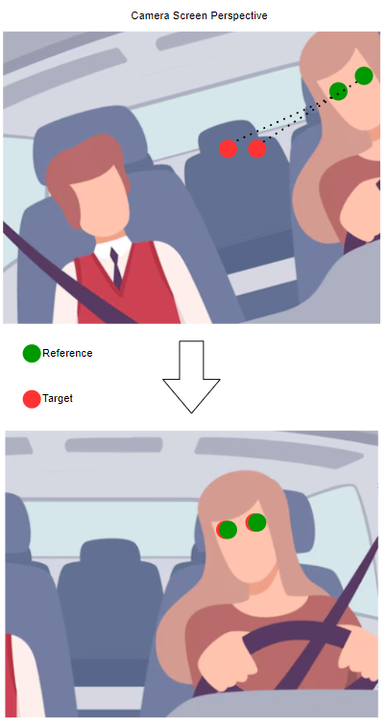

#### **Figure #10: Adjustment Process Example**

## 

## 

## 

## 

#### **Figure #11: Yaw Roll Pitch Diagram**

F = 3(N − J − 1) + $\sum_{i = 1}^{j}{}$ fi

The Gruebler’s equation is used to find the degree of freedom for the ABENICS ball joint where N is the number of links, J is the number of joints and fi is the Dof of the ith joint.

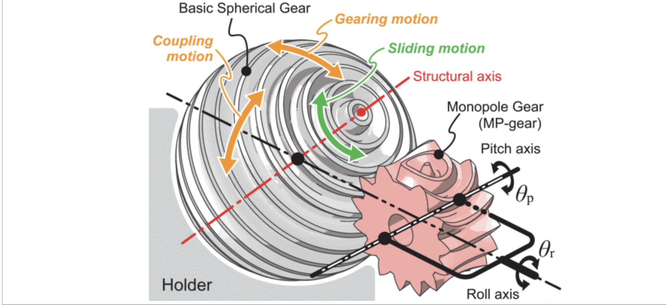

#### **Figure#12: ABENICS Joint**

## **8.6 Appendix F Data Sheets**

### **8.6.1 Raspberry Pi 4 Model B datasheet**

#### **Figure #13: Raspberry Pi 4 Model B Pinout Diagram[3]**

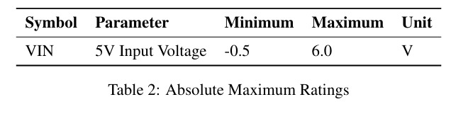

#### **Figure #14: Minimum & Maximum Voltage Input [4]**

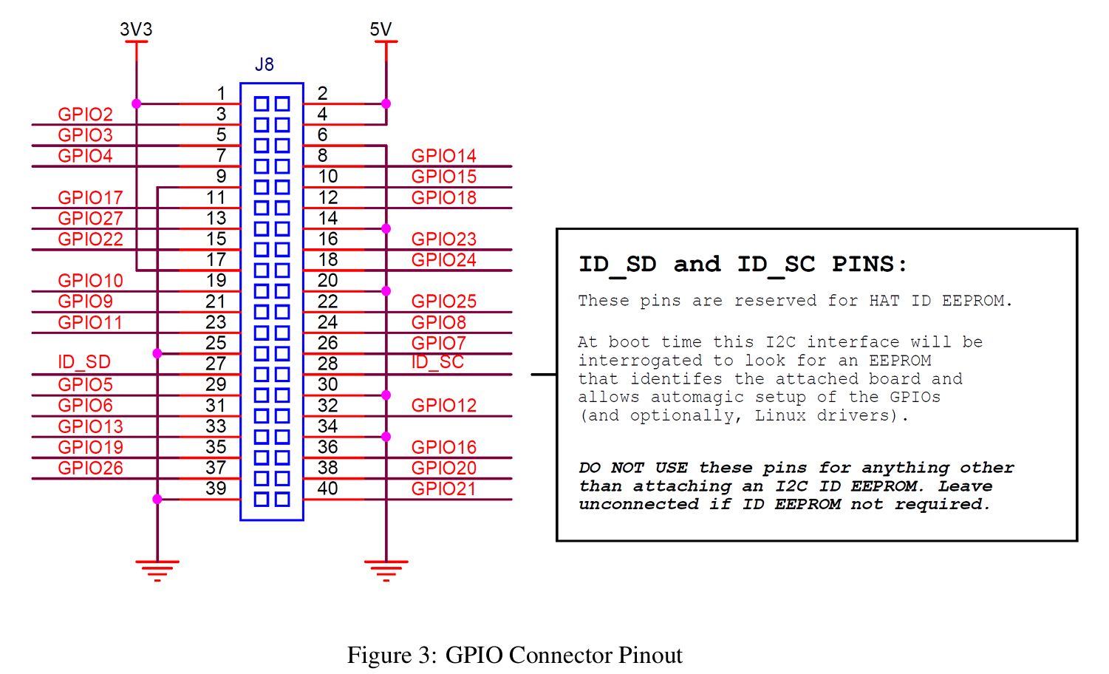

#### **Figure #15: Raspberry Pi Pinout Diagram**[5]

**Specifications (Raspberry Pi Foundation, 2023):**

* 2 × micro HDMI
* 2 × USB 2.0
* 2 × USB 3.0
* CSI camera port
* DSI display port
* 3.5mm AV jack
* PoE-capable Gigabit Ethernet (1Gb/s)
* 2.4/5GHz dual-band 802.11ac Wi-Fi (120Mb/s)
* Bluetooth 5, Bluetooth Low Energy (BLE)
* microSD card slot
* USB-C power (5V, 3A (15W))
* 4GB ram[6]

### **8.6.2 Raspberry Pi Camera Module V2 datasheet**

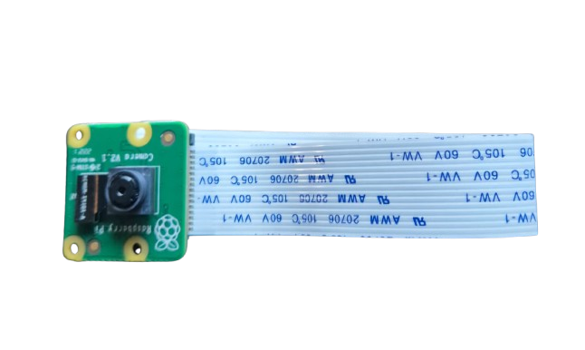

#### **Figure #16: Raspberry Pi Camera Module V2[7]**

**Specifications (Raspberry Pi Foundation, 2023):**

* 8 megapixel camera
* Photographies at 3280 x 2464 pixels
* Videos at 1080p47, 1640 × 1232p41 and 640 × 480p206 resolutions
* Software supports the latest version of Raspbian Operating System
* Sensor: Sony IMX219
* Weight: 3g
* Voltage: 3.3 volts

### **8.6.3 Greartisan Gear Motor datasheet**

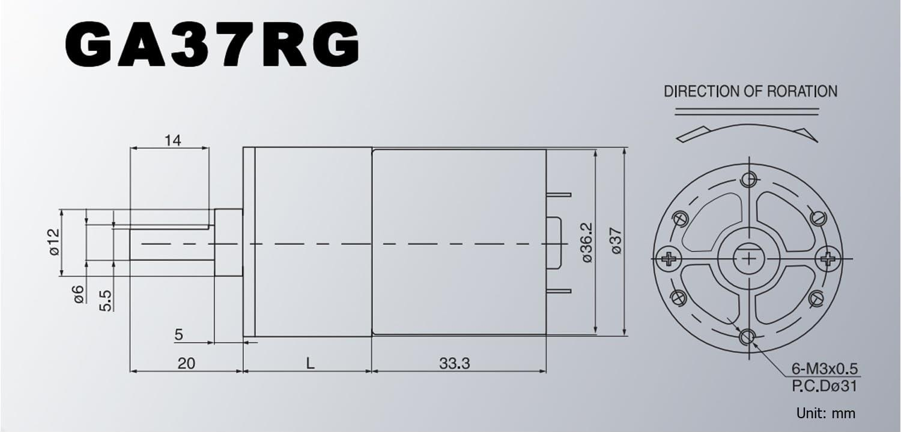

#### **Figure #17: Greartisan DC 12V 10RPM, 37mm Diameter Gearbox[8]**

**Specifications:**

* Voltage: DC 12V
* Reduction Ratio: 1:401
* No-Load Speed: 10RiPM
* No-Load Current: 0.15 Amp
* Rated Torque: 15 kg/cm
* Rated Current: 0.6 Amp
* D Shaped Output Shaft Size: 6 x 14 mm (0.24” x 0.55”)
* Gearbox Size: 37 x 30.5 mm (1.46” x 1.2”)
* Motor Size: 36.2 x 33.3 mm (1.43” x 1.31”)
* Mounting Hole Size: M3 (not included)

### **8.6.4 3 mm LED Datasheet**

# 

#### **Figure #18: 3mm LED Datasheet[9]**

**Specifications:**

* Power dissipation : 66mW
* Reverse Voltage : 4 V
* D.C. Forward Current:30mA
* Operating Temperature Range:-25 to + 85°C
* Peak Current (1 / 10 Duty Cycle, 0.1ms Pulse Width) :100 mA
* Reverse (Leakage) Current:100 μA
* Luminous Intensity: 20 mA

### **8.6.5 L293D Datasheet**

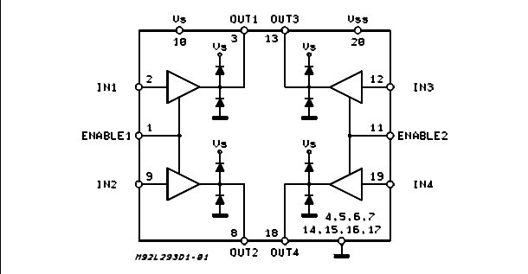

#### **Figure #19: L293D Push-Pull Four Channel Drivers with Diodes, Block Diagram[10]**

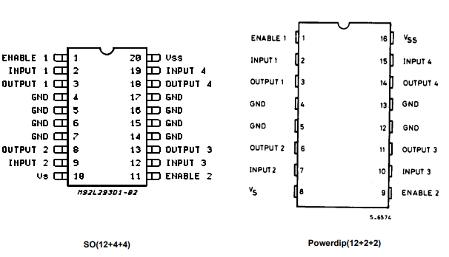

#### **Figure #20: L293D, Pin Connections**

**Specification:**

* Logic Supply Voltage: Min. - 4.5V; Max - 36V
* Total Quiescent Supply Current (pin 10) -Typ. - 2 mA; Max - 6 mA
* Total Quiescent Supply Current (pin 20) -Typ. - 16 mA; Max - 24 mA
* Internal Clamp Diodes
* 600ma Output Current Capability Per Channel
* Enable Facility
* 1.2a Peak Output Current (Non Repetitive) Per Channel
* Logical \"0\" Input Voltage Up To 1.5 V (High Noise Immunity)
* Overtemperature Protection

# 

# **9.0 References**

Allied Market Research. (2024). *Car sharing market by service type, vehicle type, and application: Global opportunity analysis and industry forecast, 2023-2032*.<https://www.alliedmarketresearch.com/car-sharing-market-A07125>

National Household Travel Survey. (2022). *2022 National Household Travel Survey summary of travel trends*. Oak Ridge National Laboratory.<https://nhts.ornl.gov/assets/2022/pub/2022_NHTS_Summary_Travel_Trends.pdf>

Nationwide Disability Representatives. (n.d.). *Avoid blind spot collisions.*<https://www.nationwidedisabilityrepresentatives.com/blog/avoid-blind-spot-collisions/#:~:text=According%20to%20the%20National%20Highway,year%20in%20the%20United%20States>

European Patent Office, Method for controlling automatically for car rear view mirror employing driver's eye location and apparatus thereof

. (2020). *Patent KR102135305B1: Description.*<https://worldwide.espacenet.com/publicationDetails/description?CC=KR&NR=102135305B1&KC=B1&FT=D&ND=&date=20200717&DB=EPODOC&locale=>

Karvir, S. (2023). Automatic Adjustable Rear-View Mirror Using Servo Motor and Arduino for Bikes. *International Journal for Research in Applied Science and Engineering Technology*. <https://doi.org/10.22214/ijraset.2023.57169>

Rota, F., & Stefano, L. (2017). Automatically adjustable rear mirror based on computer vision. *2017 International Conference of Electrical and Electronic Technologies for Automotive*, 1-7. <https://doi.org/10.23919/eeta.2017.7993218>

Blincoe, L., Miller, T., Wang, J.-S., Swedler, D., Coughlin, T., Lawrence, B., Guo, F., Klauer, S., & Dingus, T. (2023, February). *The economic and societal impact of motor vehicle crashes, 2019 (Revised)* (Report No. DOT HS 813 403). National Highway Traffic Safety Administration. [The Economic and Societal Impact of Motor Vehicle Crashes, 2019 (Revised) (dot.gov)](https://crashstats.nhtsa.dot.gov/Api/Public/ViewPublication/813403.pdf)

*Safety first: car crashes, innovation, and why federal policy should prioritize adoption of existing technologies to save lives - CR Advocacy*. (2020, June 28). CR Advocacy. <https://advocacy.consumerreports.org/research/cr-safety-first-car-crashes-innovation-federal-policy-study/>

Abe, K., Tadakuma, K., & Tadakuma, R. (2021). ABENICS: Active ball joint mechanism with three-DoF based on spherical gear meshings. IEEE Transactions on Robotics. Retrieved from <https://doi.org/10.1109/TRO.2021.3070124>

Rouse, M. (n.d.). Microcontroller. TechTarget IoT Agenda. Retrieved October 3, 2024, from<https://www.techtarget.com/iotagenda/definition/microcontroller>

Hotjar. (n.d.). Eye tracking. Hotjar Conversion Rate Optimization Glossary. Retrieved October 3, 2024, from <https://www.hotjar.com/conversion-rate-optimization/glossary/eye-tracking/>

M. Shawky (2020), "Factors affecting lane change crashes", IATSS Res., vol. 44, no. 2, pp. 155-161, Jul. 2020. <https://www.sciencedirect.com/science/article/pii/S0386111219300020>

Valentine, Ashlee (2024); Smith, Kelly Anne (2024). Car Ownership Statistics 2024**,**

Forbes Advisor, March 2024. <https://www.forbes.com/advisor/car-insurance/car-ownership-statistics/>

Survey/Program: American Community Survey Year: 2022 Estimates: 5-Year   
Table ID: DP04 Source: [U.S. Census Bureau, 2018-2022 American Community Survey 5-Year Estimates](https://data.census.gov/table/ACSDP5Y2022.DP04?moe=true)

Raspberry Pi Foundation. (2023). *Raspberry Pi: Camera documentation*. Raspberry Pi.<https://www.raspberrypi.com/documentation/accessories/camera.html>

Raspberry Pi Foundation. (2023). *Raspberry Pi: Specifications*. Raspberry Pi.<https://www.raspberrypi.com/documentation/computers/raspberry-pi.html>

Raspberry Pi Trading Ltd. (2024). *Raspberry Pi 4 Model B datasheet: Release 1.1*.<https://datasheets.raspberrypi.com/rpi4/raspberry-pi-4-datasheet.pdf>

Greartisan Store, Amazon (2024). *Greartisan DC 12V 10RPM Gear Motor 37mm Diameter Gearbox* <https://www.amazon.com/Greartisan-Electric-Reduction-Centric-Diameter/>

Farnell (2024). *3mm LED Datasheet.*<https://www.farnell.com/datasheets/1626756.pdf>

STMicroelectronics (2024) *L293D Push-Pull Four Channel Drivers with Diodes*.   
 <https://www.st.com/en/motor-drivers/l293d.html>

1. [Case Study on Rear-View Mirror Adjustment](https://doi.org/10.1016/j.trf.2015.05.003)
2. [Car Ownership Statistics 2024](https://www.forbes.com/advisor/car-insurance/car-ownership-statistics/)
3. [Raspberry Pi 40-pin](https://www.raspberrypi.com/documentation/computers/raspberry-pi.html)
4. [Raspberry Pi 4 Model B Datasheet](https://datasheets.raspberrypi.com/rpi4/raspberry-pi-4-datasheet.pdf)
5. [Raspberry Pi 4 Model B Datasheet](https://datasheets.raspberrypi.com/rpi4/raspberry-pi-4-datasheet.pdf)
6. [Raspberry Pi 4 Model B Datasheet](https://www.raspberrypi.com/documentation/computers/raspberry-pi.html)
7. [Camera Datasheet](https://www.raspberrypi.com/documentation/accessories/camera.html)
8. [Motor Description](https://www.amazon.com/Greartisan-Electric-Reduction-Centric-Diameter/dp/B089GTHGPZ/ref=sr_1_6?dib=eyJ2IjoiMSJ9.DVWk5pLyQ_dqDp13O4lPtXmWJI-1PIDOGCXkdHtBmk8kIkbhaTpLe9H5dfid5uMbi3GzMdo-mdpM9U8yt_FHOFVe13uaeaJHaaeGRUdknU6j9w-tYt_hyOkCkRMPB_9s2DW1F7Xw3hzCqTFcXVQwW-q_n5dNwxl1b7ungHc3w41trYXV6S-P7GOEoIbjEFxIls6oe45XqJGevlB48n9pdQJbXKD7HJbBAeXC8EXyC2a_fwVbRS_tMMk0esKfpy7AN52JDr3jkJSRhn0bDPy_KWWrOlS1TwtlI6wbIr6yOF4.R0z_GKXggYmb6AjWPk86apT7ntOMUQBSAj7IEeFEk3U&dib_tag=se&keywords=high%2Btorque%2Bdc%2Bmotor&qid=1728144444&sr=8-6&th=1)
9. [3mm LED datasheet](https://www.farnell.com/datasheets/1626756.pdf)
10. [L293D Product Overview & Datasheet](https://www.st.com/en/motor-drivers/l293d.html)